This is a continuation of the series of articles that focus on the ESVMG Gardens. Each month we bring you a description of one of the lovely gardens that we have created and maintain. And, along with the description, we feature one plant from this garden about which we will provide additional insight. Hope you enjoy the articles and are inspired to visit our gardens.

Ker Place Kitchen Garden
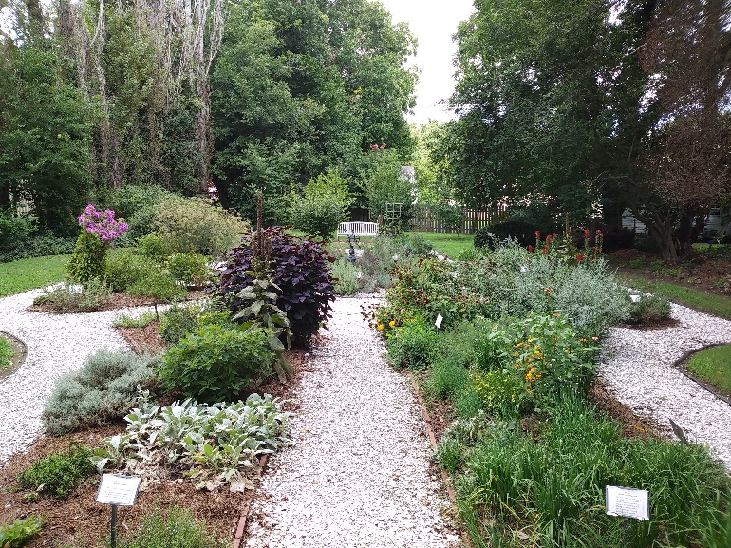
Ker Place Kitchen Garden was first conceived by Master Gardener Joanna Snyder as a project for the 2002 interns. A committee was formed in April 2003 with Fran Kubick as chairperson. The original design was based on the herb garden at the Adam Thoroughgood House in Virginia Beach and, at some point during the design process, was modified to the layout we see today.
A colonial woman relied on her kitchen garden for the health and wellbeing of her family. Herbs were critical for healing illnesses and injury as well as maintaining health and wellness by using plants in teas, poultices and tinctures. Spices were imported and, therefore, less available and more expensive. Instead, plants grown in the kitchen garden were used to add flavoring, dyes, aromatics and cosmetics.
The ESVMG volunteers are committed to maintaining the authenticity of the garden by ensuring all perennial plant varieties would have been available to the colonial household.
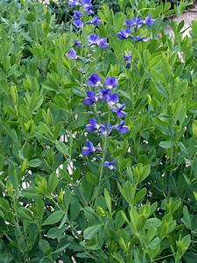
With a host of medicinal and culinary herbs grown in the garden, the volunteers had a difficult time deciding which one to be featured for this article. They finally settled on Baptisia tinctoria, commonly known as false or wild indigo. The baptisia was not a significant medicinal plant to the early colonists, however the native Americans used it for typhoid and scarlet fever. It’s primary use for the colonists was as a blue dye. Today it is used as a gargle to treat canker sores, gum infections and sore throat. More significantly Baptisia tinctoria is a plant native to the Eastern Shore and is a larval host for Frosted Elfin and Wild Indigo Duskywing butterflies.
Easily grown in average, dry to medium, well-drained soil in full sun to part shade. Best in full sun. Tolerates drought and poor soils. Over time, plants form slowly expanding clumps with deep and extensive root systems, and should not be disturbed once established.
There are sixteen Master Gardeners volunteering at Ker Place. Maintaining the garden, replanting where needed and moving plants when necessary. We have five members of the 2017-2018 class who have been invaluable in the clearing of ivy and underbrush on the east side of the garden with the intention of adding native trees and shrubs to the understory.
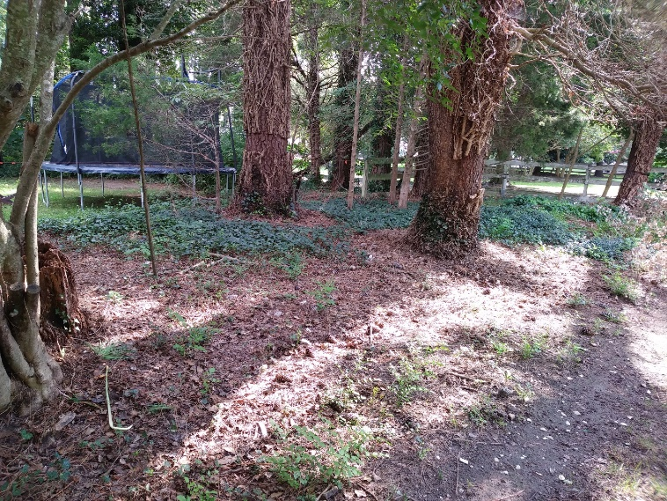
Work days are every Tuesday morning, 9:30 – 11:00.

